VIETNAM NATIONAL UNIVERSITY OF HO CHI MINH CITY
THE INTERNATIONAL UNIVERSITY
SCHOOL OF COMPUTER SCIENCE AND ENGINEERING

Web Application Development
Laboratory 1

Lê Huỳnh Thiện – ITCSIU23036

Date Performed: 04/03/2026
Date Submitted: 04/03/2026

Instructor: Tran Khai Minh

Exercise 1
Code
HTML

<!DOCTYPE html>
<html lang="en">
<head>
<meta charset="UTF-8">
<meta name="viewport" content="width=device-width, initial-scale=1.0">
<link rel="stylesheet" href="style.css">
<title>Resume</title>
</head>
<body>
<hr>
<h1>Lê Huỳnh Thiện</h1>
<h2>Junior Frontend Developer</h2>
<p>343/25 Sư Vạn Hạnh, phường Hoà Hưng, TPHCM<br>
(+84) 853826638<br>
lehuynhthien05@gmail.com
</p>

<h2>Skills</h2>
<p>HTML, CSS, JavaScript, Accessibility, Figma to Design, Responsive Web Design, Technical Writing, Presentation</p>

<h2>Education</h2>
<h4>International University, VNU HCMC, BSc. Computer Science</h4>
<p>August 2023 to August 2027</p>
<p>GPA: 3.60/4.00</p>
<p>Google Developer Groups - at International University</p>
<p>Advisor</p>

<h2>Experience</h2>
<h4>Company A, Hoa Hung Ward, HCMC - Back-End Web Developer</h4>
<p>February 2026 to June 2026</p>
<ul>
<li>Developed and built the business logic for the whole system</li>
<li>Optimized website performance</li>
</ul>
<p>Skills: Typescript, Javascript, Java - Springboot</p>

<h4>Company B, Tan Hoa Ward, HCMC - Fullstack Developer</h4>
<p>September 2026 to January 2027</p>
<ul>
<li>Assisted in the development and execution of automated test scripts</li>
<li>Assisted in running automated tests in a CI/CD pipeline</li>
<li>Conducted functional and smoke testing for web applications</li>
<li>Developed the main feature of the system and integrate them into the whole system</li>
</ul>
<p>Skills: Selenium, Java</p>

<h2>Across the Internet</h2>
<p>Github Link: <a href="https://github.com/lehuynhthien05" target="_blank">github.com/hoangnv63</a></p>

</body>
</html>

CSS

html * {
font-family: Arial;
}

h2 {
color: lightgreen;
}

h4 {
color: blue;
}

Result
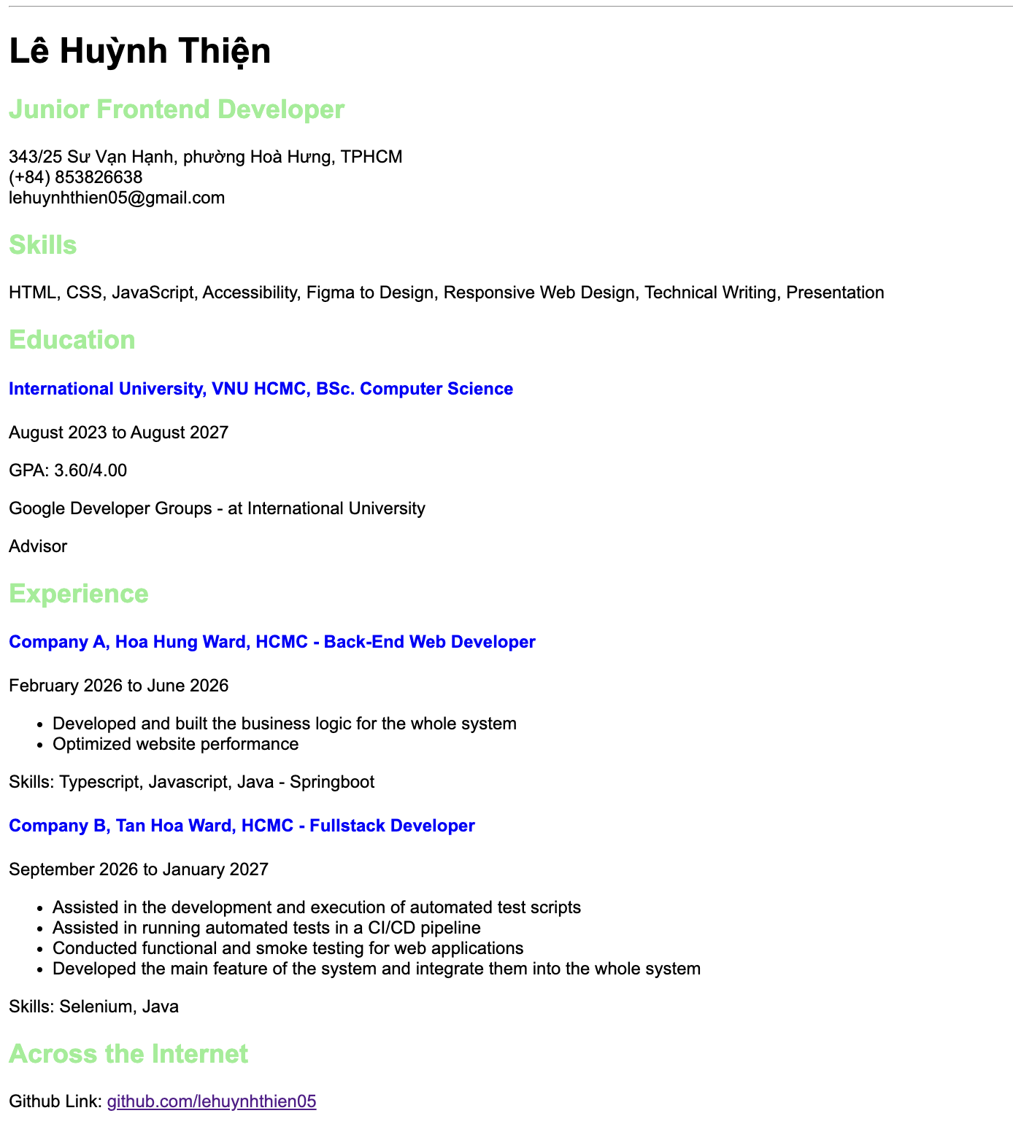

Explanation
- We use the tag heading 1 for my name; some subtitles use heading 2 or heading 4
- The information in the subtitles uses the tag "paragraph" to mark the boundaries between the information
- On the last page, we use the tag "a href" to link to my GitHub. It is the storage that we can use to store our code or some files.
- In addition, we use the style.css file to customize the HTML file, such as the color of the heading, etc.

Question 2
Code

create table student(
studentId int primary key,
studentName varchar(50) not null,
dob date not null,
major varchar(50) not null,
);

create table student_course(
courseId int not null,
studentId int not null,
primary key (courseId, studentId),
foreign key studentId references student(studentId)
foreign key courseId references course(courseId)
);

create table course(
courseId int primary key not null,
courseName varchar(50) unique,
);

create table lecturer(
lecturerId int primary key not null,
lecturerName varchar(50),
departmentId int not null,
foreign key departmentId references department(departmentId)
);

create table course_lecturer(
lecturerId int not null,
courseId int not null,
primary key (lecturerId, courseId),
foreign key lecturerId references lecturer(lecturerId),
foreign key courseId references course(courseId)
);

create table department(
departmentId int primary key not null,
departmentName varchar(50)
);

Result
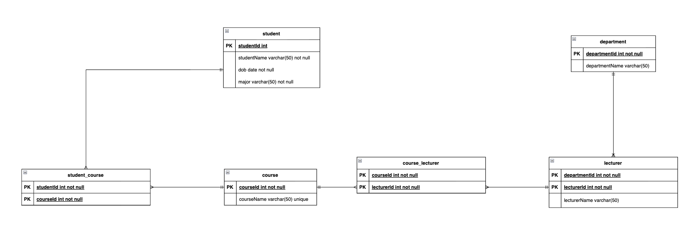
Explanation
- In the database design above, I will check the normalization of the original database design, and I redraw it like this.
- I divide the tables that have many-to-many relationship to make it clearer
- In SQL code, I make it clear that I check the constraint for the attributes that it is UNIQUE or PRIMARY KEY

